Lesson 05 XAS Resource Workbook

**Transmission Mode, Pinhole and Thickness Effects**

**Charles A. Cardot and Gerald T. Seidler**

*All lessons and all versions can be found at* [*https://github.com/XASResourceWorkbook/XASResourceWorkbook*](https://github.com/XASResourceWorkbook/XASResourceWorkbook)

*This work is licensed under* ***CC BY-NC-SA 4.0***

**

Version History:

1.0 *Month Year*: C.A. Cardot, G.T. Seidler

Lesson 05 XAS Resource Workbook

**Transmission Mode, Pinhole and Thickness Effects**

**Suggested Introductory Reading**

* Suggested Reading 1
* Suggested Reading 2

**Overview and Advanced Reading**

Intro Paragraph

I. Introduction to Transmission Mode

**Educational Goals**:

1. In the diagram below, label all the components of the Transmission mode experimental setup.

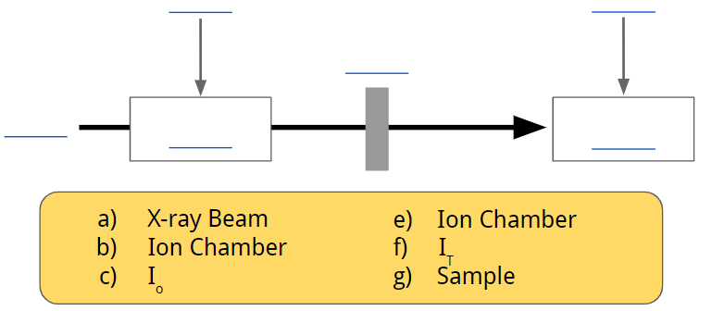

1. Find three papers that use transmission mode. What were the concentrations of the target species in these papers?
2. Why is transmission mode a poor choice when the absorption by the element of interest is very weak?
3. What is a rough estimate for the ideal thickness of a transmission mode sample in terms of the change in attenuation length above and below the edge? Explain.

## **II. Model the Pinhole Problem**

**Educational Goals**:

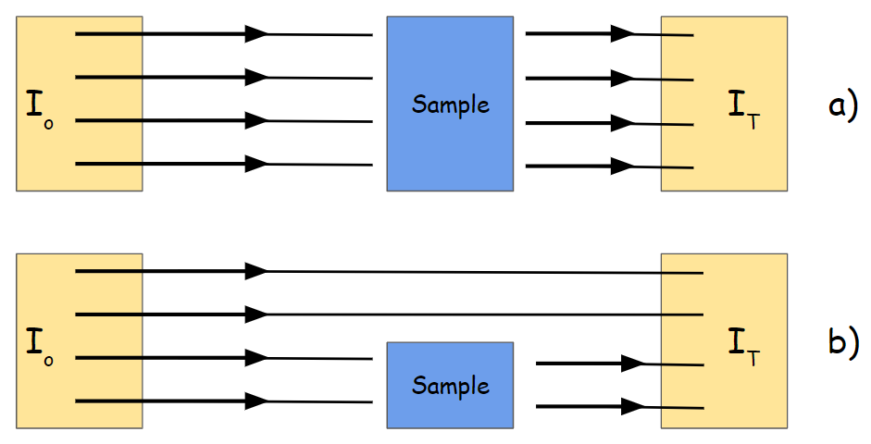

* 1. For (a) on the figure above, use Beer’s law to write an expression for the detected transmitted intensity as a function of the absorption coefficient $μ$, sample thickness $x$, and incident intensity $I_{o}$.
  2. Now, for (b), write another expression for thetransmitted signal in the case where half of the beam misses the sample but still strikes the $I_{T}$ detector.
  3. This is an idealized (serious) case of the ‘pinhole effect’ in transmission mode XAFS. In real experiments, it comes from inhomogeneous samples where the actual density/thickness of the sample varies over the area of the beam. Why might experimental complications arise from this effect?
  4. Now we are going to do a little analysis on this problem. Use the $μ$ from the signal that you found in the question B (hereafter referred to as $μ'$) and put it in terms of the actual $μ$ of the sample and the sample thickness $x$. Then, on the empty graph below plot two curves: the first being $μ'x$ as a function of $μx$, and the second being .

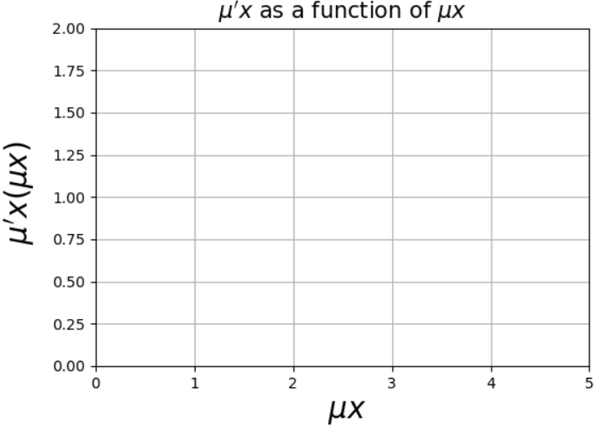

* 1. Based on your plot in the previous problem, make a prediction on how you expect the features in the XAFS to be affected by the pinhole. In the example that we looked in question B, the apparent sample was actually 50% pinhole, meaning that half the of incident beam entirely missed the sample. How do you expect the XAFS spectra to change for different pinhole percentages?

## **III. Simulate the Problem:** Below are simulated XAFS spectra for V2O5 sample, take from <https://xaslib.xrayabsorption.org/elem/>, which are composed of 0%, 10%, 25%, 50%, and 75% pinholes. 0% means that there are no pinholes, and the transmission intensity directly follows the expression you found earlier. Observe how the pinhole percentage affects the XAFS and then answer the following questions.

**Educational Goals**:

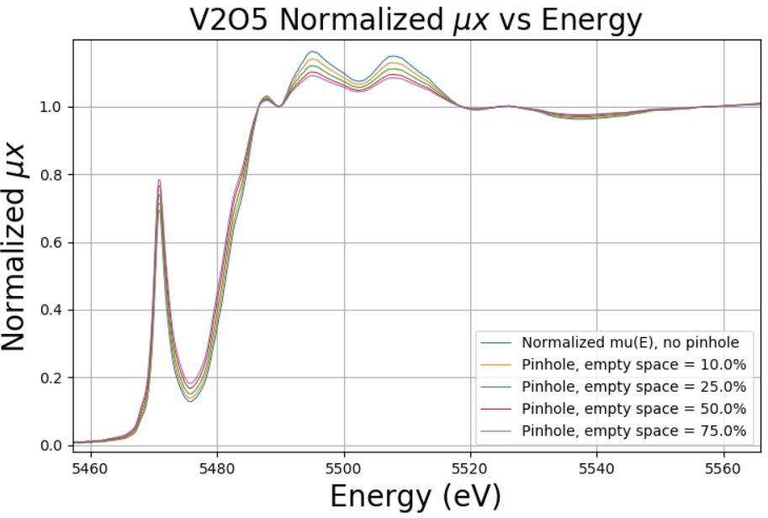

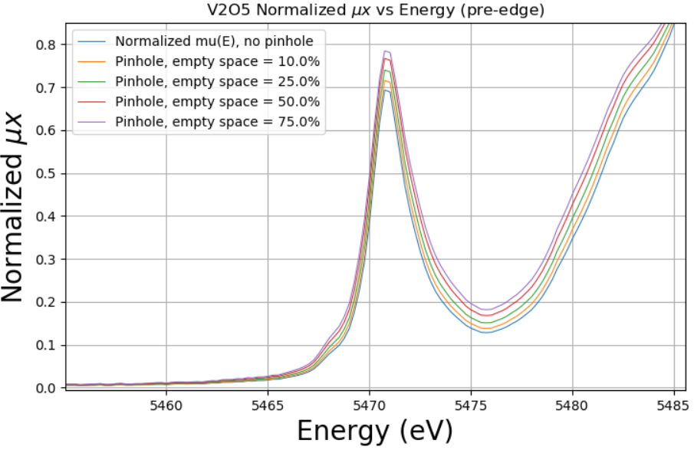

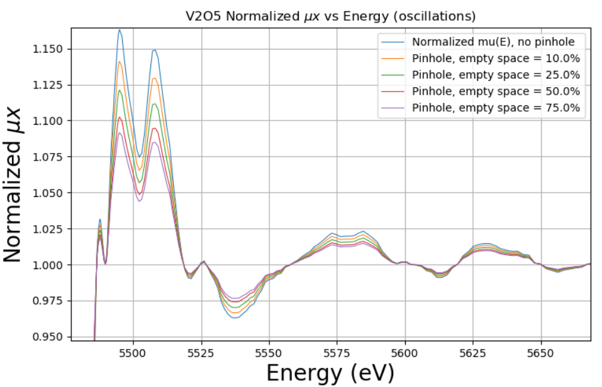

* 1. What appears to be happening to the oscillations in the XAFS? Does this agree with what you predicted based on the relationship you derived between $μ'x$ and $μx$?
  2. Below is a graph of the raw (unnormalized) $μx$. Comment on how the edge height changes with changes with pinhole percentage. Why might this be an issue for the signal to noise ratio?

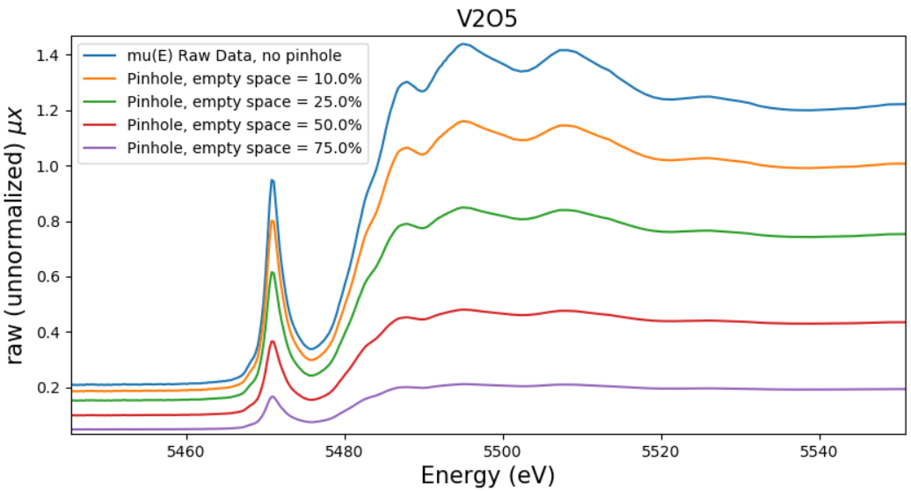

* 1. Below is a rough plot of the height of the pre-edge feature relative to the height of the rising edge. What does this indicate about the reliability of the height of the pre-edge peaks when inhomogeneities are present in the sample?

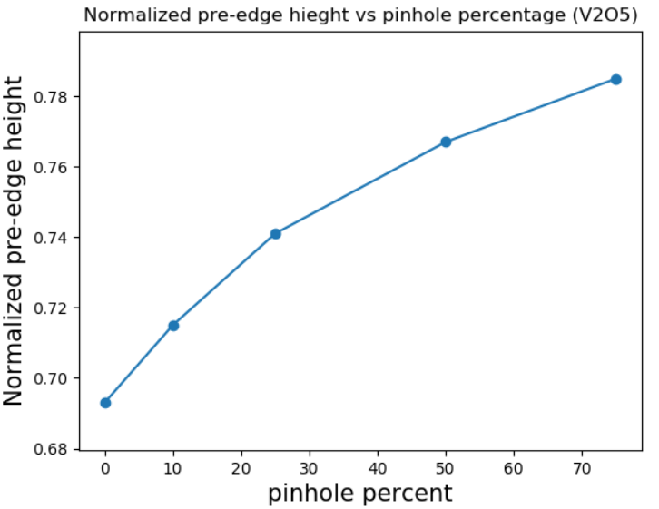

* 1. As shown in the previous problem, the normalized pre-edge peak actually grows with pinhole percentage. This is not just an artifact of the normalization though. If you were to zoom in on the pre-edge peaks in the plot of unnormalized $μx$, you would see that the peaks grow relative to the edge step (which is being normalized to 1). However, the amplitudes of the oscillations in the EXAFS region instead get smaller relative to the edge step. Explain why this is. (Hint: Consider the plot you made of earlier with the two curves $μ'x$ as a function of $μx$, and $μ'x = μx$.)

III. Thickness and Grain Size

1. If a sample is non homogeneous in the sense that some parts of the sample are thicker/denser than others, how is this analogous to the pinhole effect?
2. Grain size is also an important consideration, and is part of the reason why samples used in transmission mode must be made sufficiently homogeneous. In the diagram shown below, a sample pellet is made up of a number of large grains when the x-ray beam of intensity $I_{o}$ interacts with it. Draw a rough image of an “equivalent sample” which is a continuous version of the grain picture to represent how much material of interest the x-rays actually interact with before exiting. If you’re having trouble visualizing what the equivalent sample should look like, just think of it as “width” on the y axis, and “thickness” (with regards to the amount of sample the x-rays interact with) on the x axis.

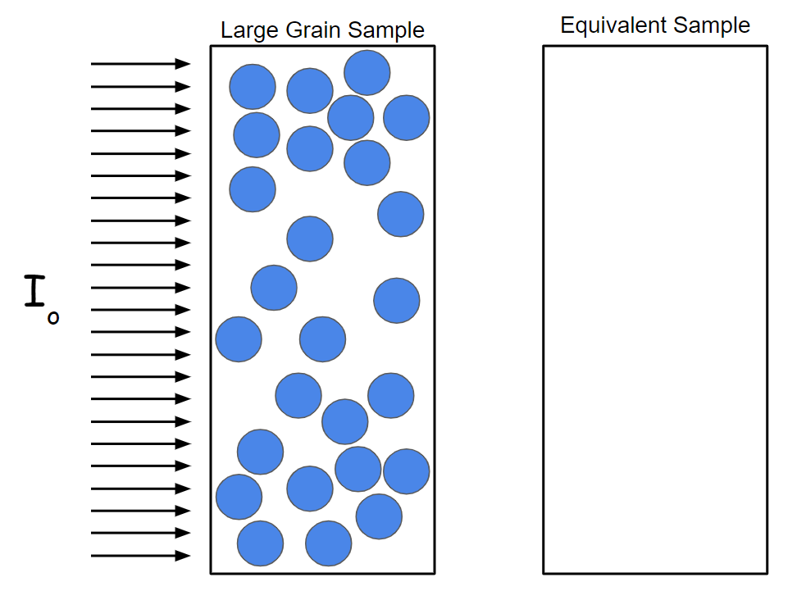

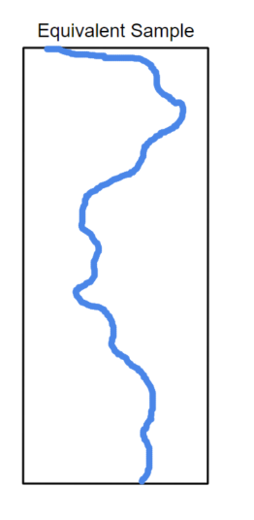

**Solution:** Converting from the large grains to a continuous version of the sample, the sample is thicker near the top and bottom in this cross-sectional image, with it being less thick in the middle.

1. Given this, how should samples be prepared for transmission mode? What metric of the material might you use to determine how homogeneous a sample needs to be? You may find it helpful to review Bunker, *Introduction to XAFS: a Practical Guide to X-Ray Absorption Fine Structure Spectroscopy*, Chapter 3.7.